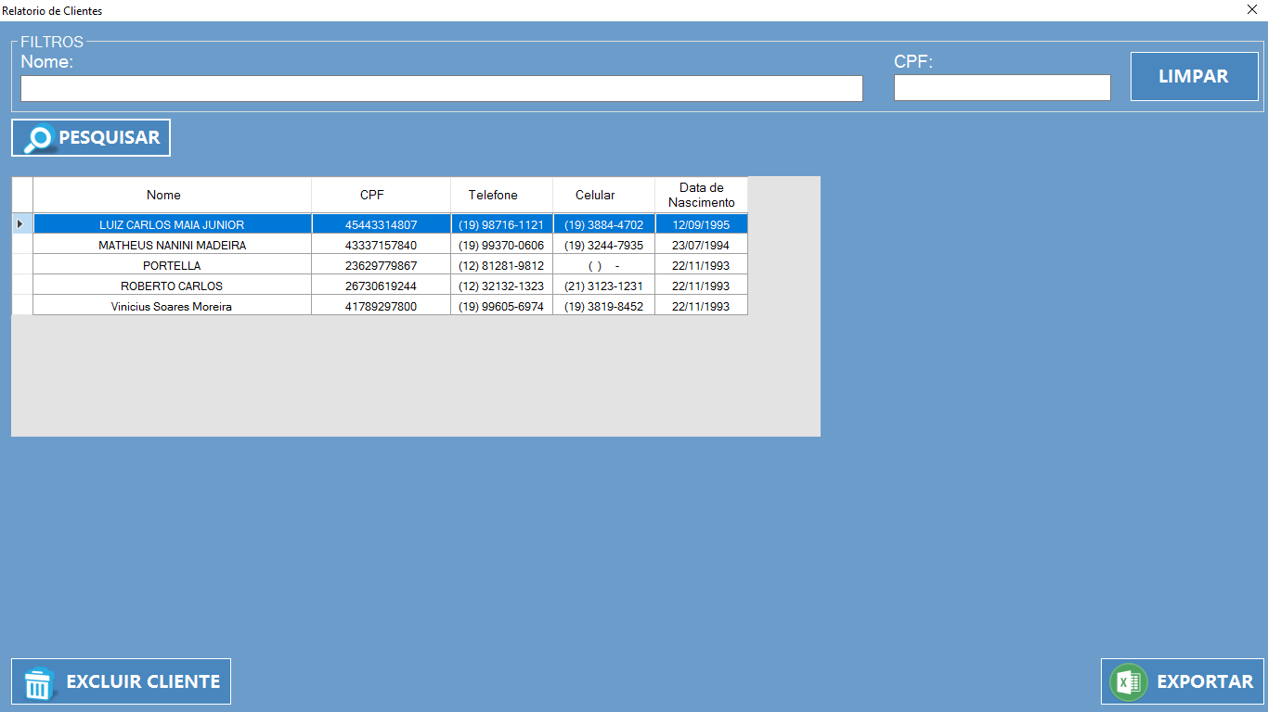

|  |  |  |  |  |
| --- | --- | --- | --- | --- |
| **CT NO.** | **PROPOSITO** | | | |
| **1** | **VERIFICAR SE IRA GERAR O RELATORIO** | | | |
| **PRÉ-CONDIÇÕES** | | | | |
| **Não tem** | | | | |
| **ENTRADA 1** | | **ENTRADA 2** | **ENTRADA 3** | **ENTRADA 4** |
| **NOME** | | **CPF** | **BOTAO LIMPAR** | **BOTAO PESQUISAR** |
| **ENTRADA5** | | **ENTRADA 6** |  |  |
| **BOTAO EXCLUIR** | | **BOTAO EXPORTAR** |  |  |
| **SAÍDAS ESPERADAS** | | | | |
| **RELATORIO GERADO** | | | | |

|  |  |  |  |  |  |
| --- | --- | --- | --- | --- | --- |
| **TESTE No.** | **NOME** | **CPF** |  |  | **BOTAO** |
| **1** | **LUIS** | **406342416** |  |  | **PESQUISAR** |
| **SAIDA ESPERADA** | | | | | |
| **MENSAGEM DE ERRO** | | | | | |

|  |  |  |  |  |  |
| --- | --- | --- | --- | --- | --- |
| **TESTE No.** | **NOME** | **CPF** |  |  | **BOTAO** |
| **2** | **LUIZ CARLOS MAIA JUNIOR** |  |  |  | **PESQUISAR** |
| **SAIDA ESPERADA** | | | | | |
| **RELATORIO**  **GERADO** | | | | | |

|  |  |  |  |  |  |
| --- | --- | --- | --- | --- | --- |
| **TESTE No.** | **NOME** | **CPF** |  |  | **BOTAO** |
| **3** | **-** | **-** | **-** |  | **PESQUISAR** |
| **SAIDA ESPERADA** | | | | | |
| **MENSAGEM DE ERRO** | | | | | |

|  |  |  |  |  |  |
| --- | --- | --- | --- | --- | --- |
| **TESTE No.** | **NOME** | **CPF** |  |  | **BOTAO** |
| **4** | **VINICIUS SOARES MOREIRA** | **417.892.978-00** |  |  | **PESQUISAR** |
| **SAIDA ESPERADA** | | | | | |
| **RELATORIO**  **GERADO** | | | | | |

|  |  |  |  |  |  |
| --- | --- | --- | --- | --- | --- |
| **TESTE No.** | **NOME** | **CPF** |  |  | **BOTAO** |
| **5** | **VINICIUS SOARES MOREIRA** | **417.892.978-00** |  |  | **EXCLUIR** |
| **SAIDA ESPERADA** | | | | | |
| **EXCLUSAO DE CLIENTE** | | | | | |

|  |  |  |  |  |  |
| --- | --- | --- | --- | --- | --- |
| **TESTE No.** | **NOME** | **CPF** |  |  | **BOTAO** |
| **6** | **MATHEUS NANIN DE S MADEIRA** | **433.371.578-40** |  |  | **EXPORTAR** |
| **SAIDA ESPERADA** | | | | | |
| **RELATORIO**  **GERADO** | | | | | |

|  |  |  |  |  |  |  |
| --- | --- | --- | --- | --- | --- | --- |
| **Aplicado em** | **Aplicado**  **por** | **Quantidade**  **de falhas** | **Depurado por** | **Reaplicado**  **em** | **Reaplicado**  **por** | **Quantidade**  **de falhas** |
| **30/10/2017** | **Luiz** | **3** | **Vinicius** | **03/11/2017** | **Luiz** | **0** |